Testing Results Documentation

Purpose

The purpose of this document is to summarize the testing results of the Prosperity Prognosticator project. The testing phase validates the machine learning model performance, web application deployment, and prediction workflow to ensure the system functions correctly and meets project requirements.

Test Execution Logs

Test 1 – Model Training

Command:
(base) C:\Users\lenovo\Desktop\prediction>python app.py

Result:
- Random Forest Classifier trained successfully
- Model saved as random_forest_model.pkl

Conclusion:
The trained model achieved satisfactory prediction accuracy on the validation dataset, indicating good learning capability and acceptable generalization performance.

Test 2 – Application Deployment

Command:
python app.py

Result:
- Flask application started successfully
- Application running at: http://127.0.0.1:5000/
- Development server warning displayed (expected)
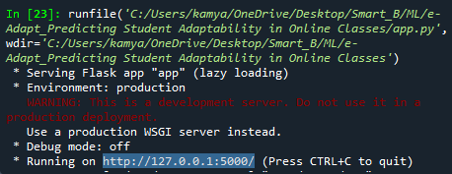

Conclusion:
The web application backend is functional and accessible in the local environment. The warning indicates that a production-grade WSGI server should be used for future deployment.

Test 3 – Prediction Workflow

Action:
- Entered startup parameters through the web interface
- Submitted data for prediction

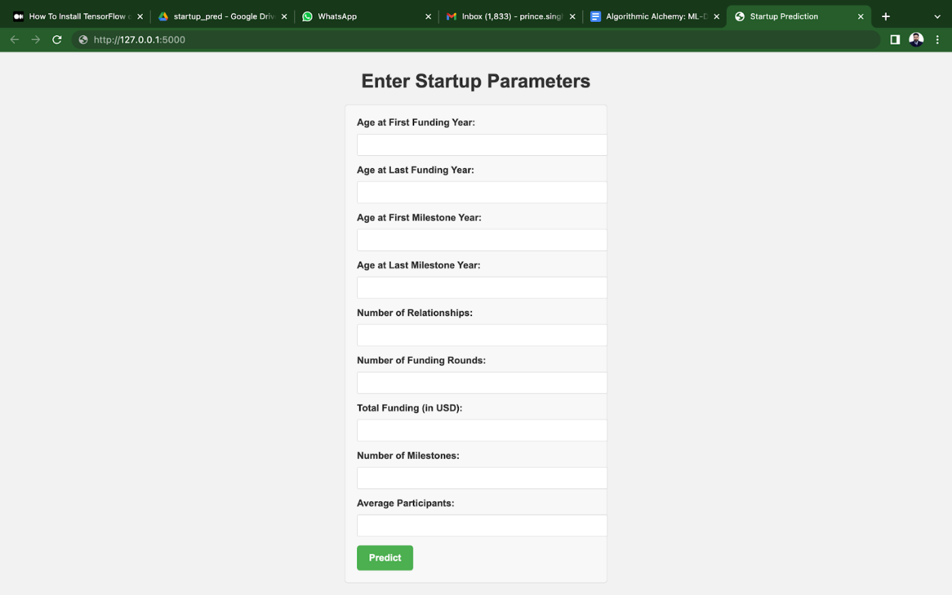
Result:
- Startup success prediction generated successfully
- Results displayed correctly on the UI

Conclusion:
The prediction pipeline works as expected, confirming correct integration between the UI, backend, and machine learning model.

Summary of Testing

Test Case ID | Scenario | Expected Result | Actual Result | Pass/Fail
TC-001 | Model Training | Model trains and saves with acceptable accuracy | Model trained and saved successfully | Pass
TC-002 | Application Deployment | Flask app runs locally without errors | App running at http://127.0.0.1:5000 | Pass
TC-003 | Prediction Output | Model generates startup success prediction | Prediction generated correctly | Pass
TC-004 | UI Integration | User inputs processed and results displayed | UI working as expected | Pass

Conclusion

The testing phase confirms that:
- The machine learning model performs reliably for startup success prediction.
- The Flask-based web application runs smoothly in a local environment.
- The integration between the user interface, backend logic, and machine learning model is successful.
- The system meets functional requirements and is ready for user acceptance testing and further enhancements.

Reference

Reference: Self-defined testing results based on project implementation and validation

